

# StudienArbeit Nr. 674

**Investigation of two CFD validation test cases for turbulent mixing of different gaseous species (fuel and oxidizer) in typical laboratory flame configurations**

Mr. Malav M Soni Matriculation Number: 4360054

Submitted to: Jun.-Prof. Dr. Rinie A. D. Akkermans

Institut für Strömungsmechanik Herrmann-Blenk-Straße 37

38108 Braunschweig Deutschland

Supervisor: Dr. rer. nat. Thorsten J. Möller Publication:

**Acknowledgment**

Firstly I would like to thank my supervisor; Dr Thorsten J. Möller, Institut für Strömungs-Mechanik, Technische Universität Braunschweig, for all the support and constant encouragement throughout the duration of my work.

I would like to take this opportunity and express my deep gratitude towards ANSYS Germany GmbH, for allowing me to carry out my work and providing me with the excellent facilities for my work. I would like to express my sincere gratitude to my supervisor at ANSYS Germany GmbH, Dr.Thomas Frank for his aspiring guidance, patience, motivation, and immense knowledge. Dr. Frank, you have been an excellent mentor for me. I would like to express my warm thanks to my colleagues Dr. Hendrik Forkel for providing me with the insightful ideas and sharing his simulation Knowledge with me. I would like to also acknowledge Marc Kainz at ANSYS Germany GmbH for his help and suggestions related to the mesh generation.

Lastly, I would express my sincere thanks to other students; Monzer Rayya and Yunqing Dong at ANSYS Germany GmbH for all the motivational, simulating talks and productive discussions during my stay at ANSYS Germany GmbH.

**ABSTRACT**:

Primary purpose of this study is to validate the two test cases viz. Sandia national laboratory propane jet and Sydney bluff body jet flame against the turbulence models available in ANSYS CFX 16.1 and ANSYS Fluent 17.0. This study is divided in to two sections a) Investigation of Sandia propane jet b) Investigation of Sydney Bluff body jet. Both investigations involve simulations carried out under isothermal, non-reacting and steady state conditions. Sandia propane jet configuration involves quasi-2D meshes, defined as the 2D mesh rotated by 5° in the circumferential direction, used for computation. In order to validate the test configurations numerically the turbulence models k-ω SST, k-ε, BSL RSM (Base Line Reynolds Stress Model) and EARSM (Explicit Algebraic Reynolds Stress Model) from ANSYS CFX 16.1 and k-ω SST, standard k-ε, realizable k-ε models from ANSYS Fluent 17.0 were used. Round jet anomaly phenomenon was addressed and modification in the dissipation (ε) equation of k-ε model was applied and the results compared with the experimental data. In the second case study with Sydney Bluff Body Jet flame involved full 3D meshes for the numerical investigation. Investigation was carried out with k-ω SST and k-ε turbulence models in ANSYS CFX 16.1 and k-ω SST, standard k-ε and realizable k-ε turbulence model in ANSYS Fluent 17.0.

In the Sandia Propane Jet case, a small single vortex recirculation region was obtained behind the bluff body. Centerline jet velocity in case of mean axial velocity (U m/s) component, compared with the experimental data, was under-predicted by all RANS models used for this investigation. The reason for this can be the simplifying assumptions made in the RANS models i.e. isotropic turbulence and round jet anomaly phenomenon. Results from modification in the constant delivered that, on one side improvement is obtained in the results of certain quantity and on other side there is deterioration in the result of other quantity. Difficulties in order to achieve convergence were observed in the k-ε turbulence models, but they delivered results that were in good agreement with the experimental data along with k-ω SST model.

In the Sydney Bluff Body jet case, a double vortex recirculation region is obtained behind the bluff body. Three mixing layers are observed in the recirculation zone. It was found that the smaller vortex near the jet loses the circulation pattern with the increase in the momentum of jet fuel. It was observed from the comparison of the mixture fraction profile with the experimental data that k-ω SST turbulence model, in ANSYS CFX 16.1, over-predicts the mixing slightly in certain locations of the domain. Realizable k-ε model, in ANSYS Fluent 17.0, over-predicted the mixing significantly, in certain domain locations, as observed from the mixture fraction comparison plots. Apart from that other turbulence models were in good agreement with each other as well as the experimental data.

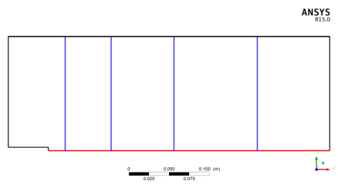 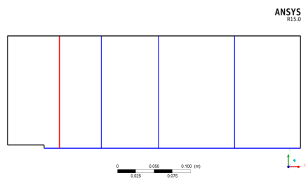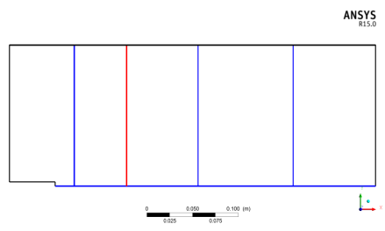

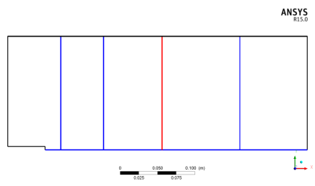

**Appendix**

**1. Sandia Propane Jet**

**1.1. Iteration or Convergence Error ANSYS CFX 16.1**

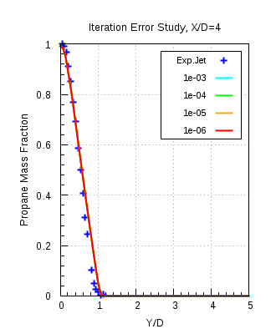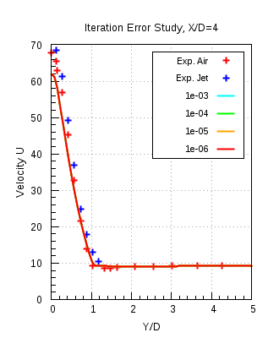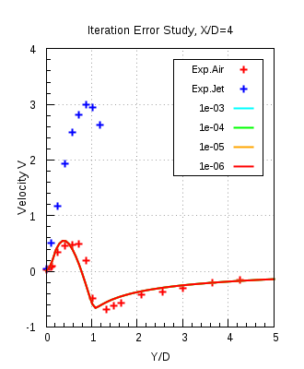

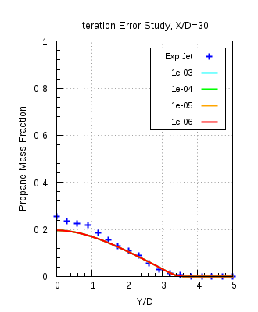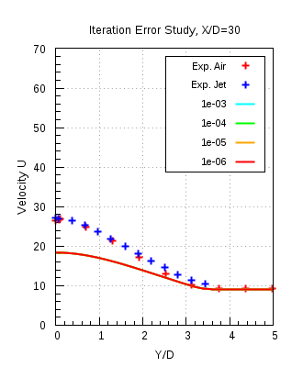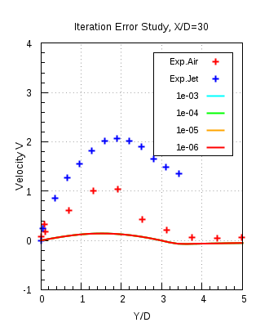

Figure 1

**Propane Mass fraction difference contours**

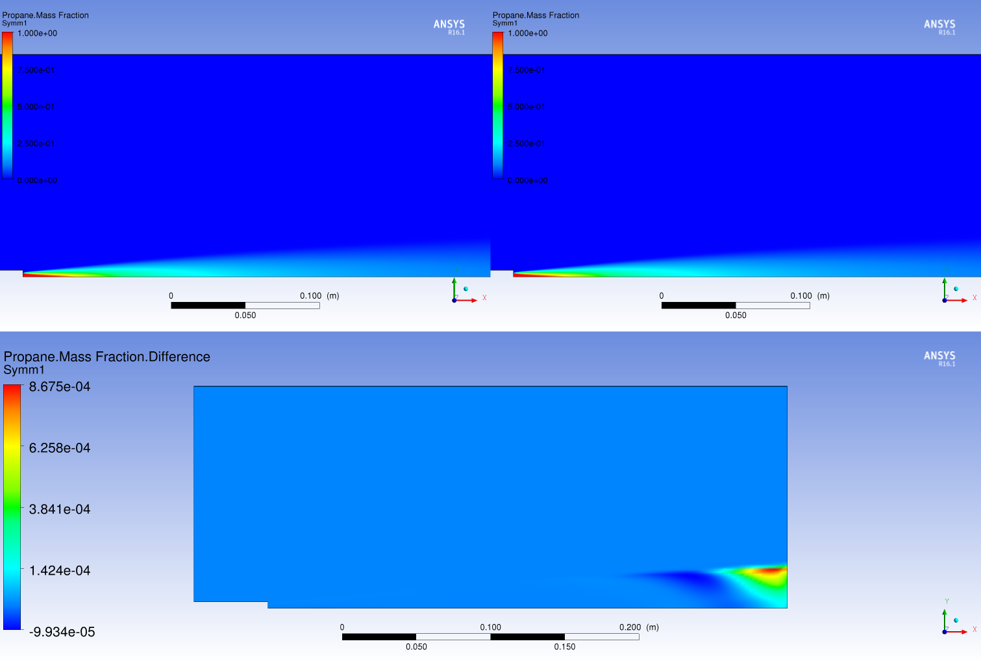

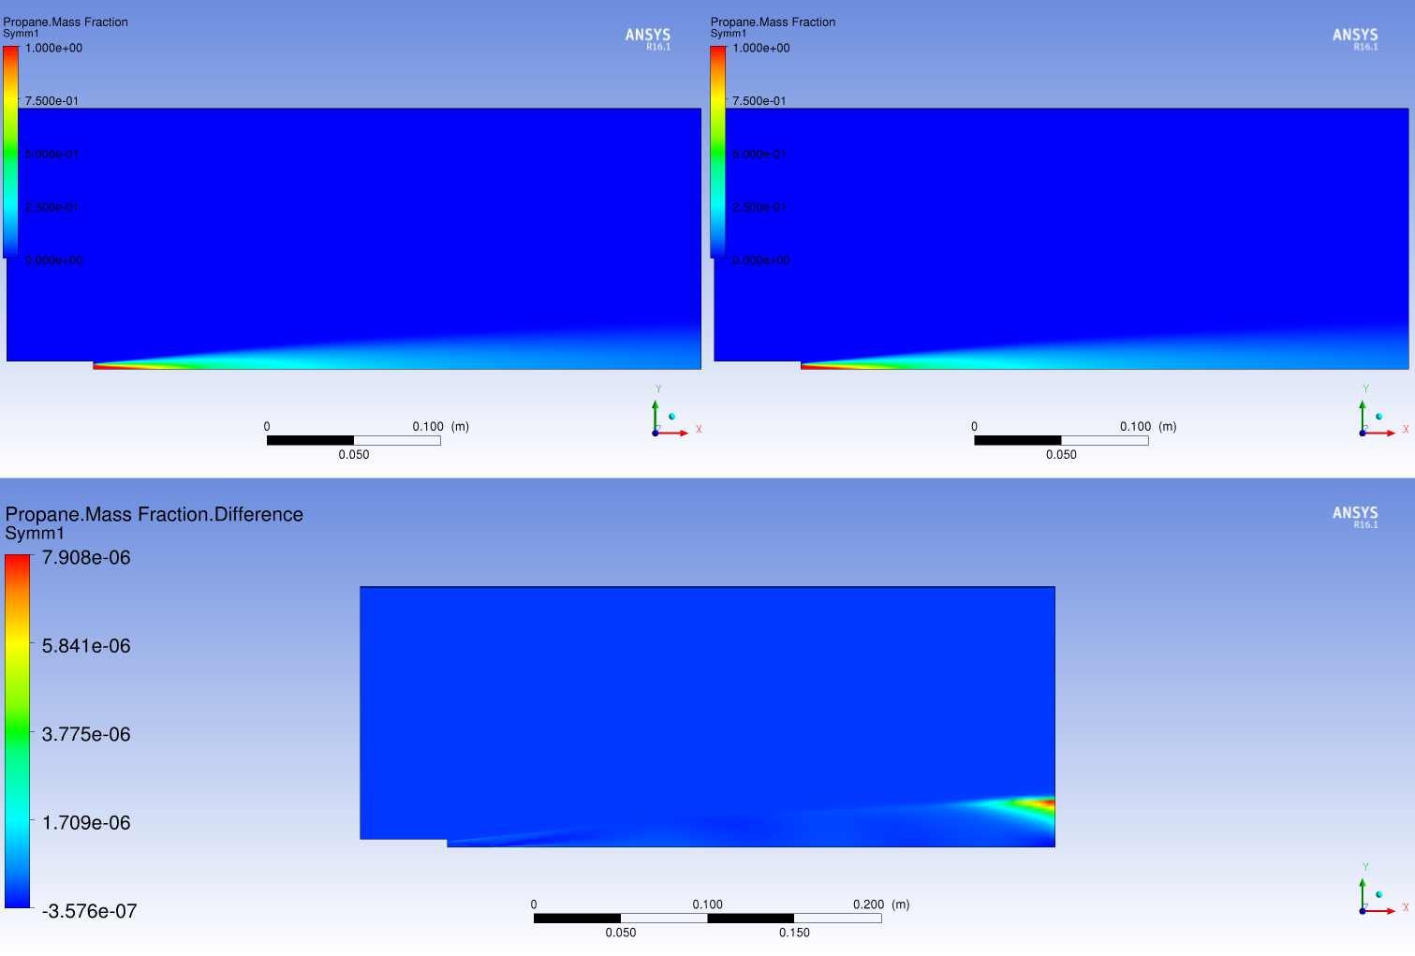

Figure 2

**Spatial Discretisation Error for ANSYS CFX 16.1**

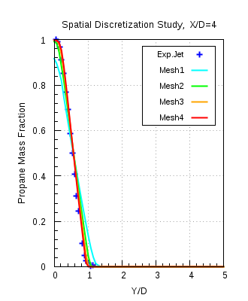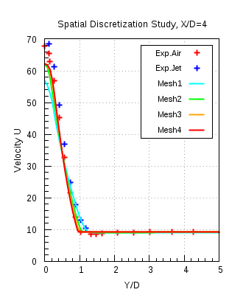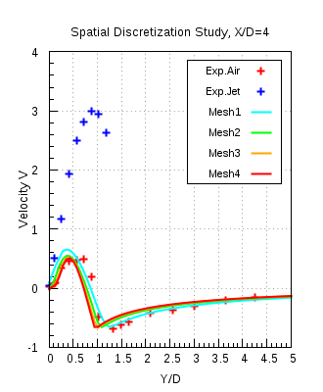

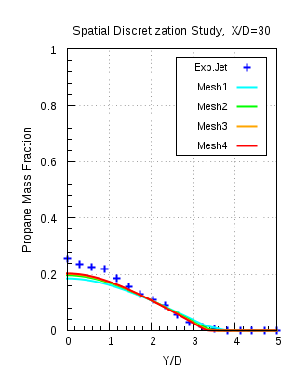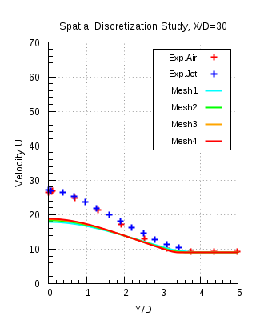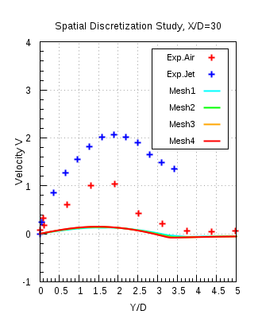

Figure 3

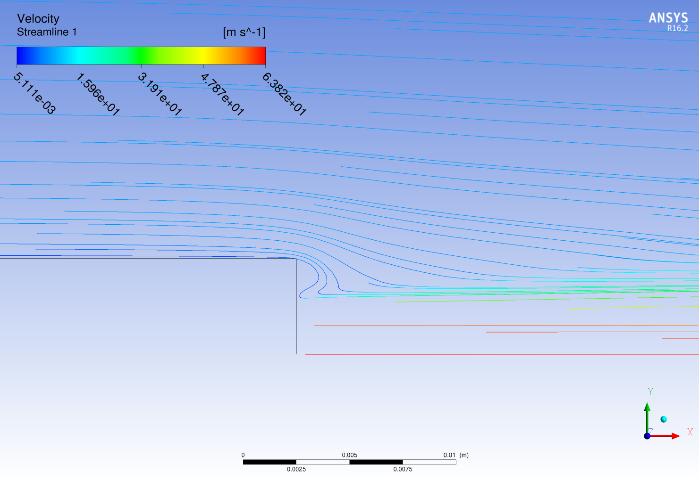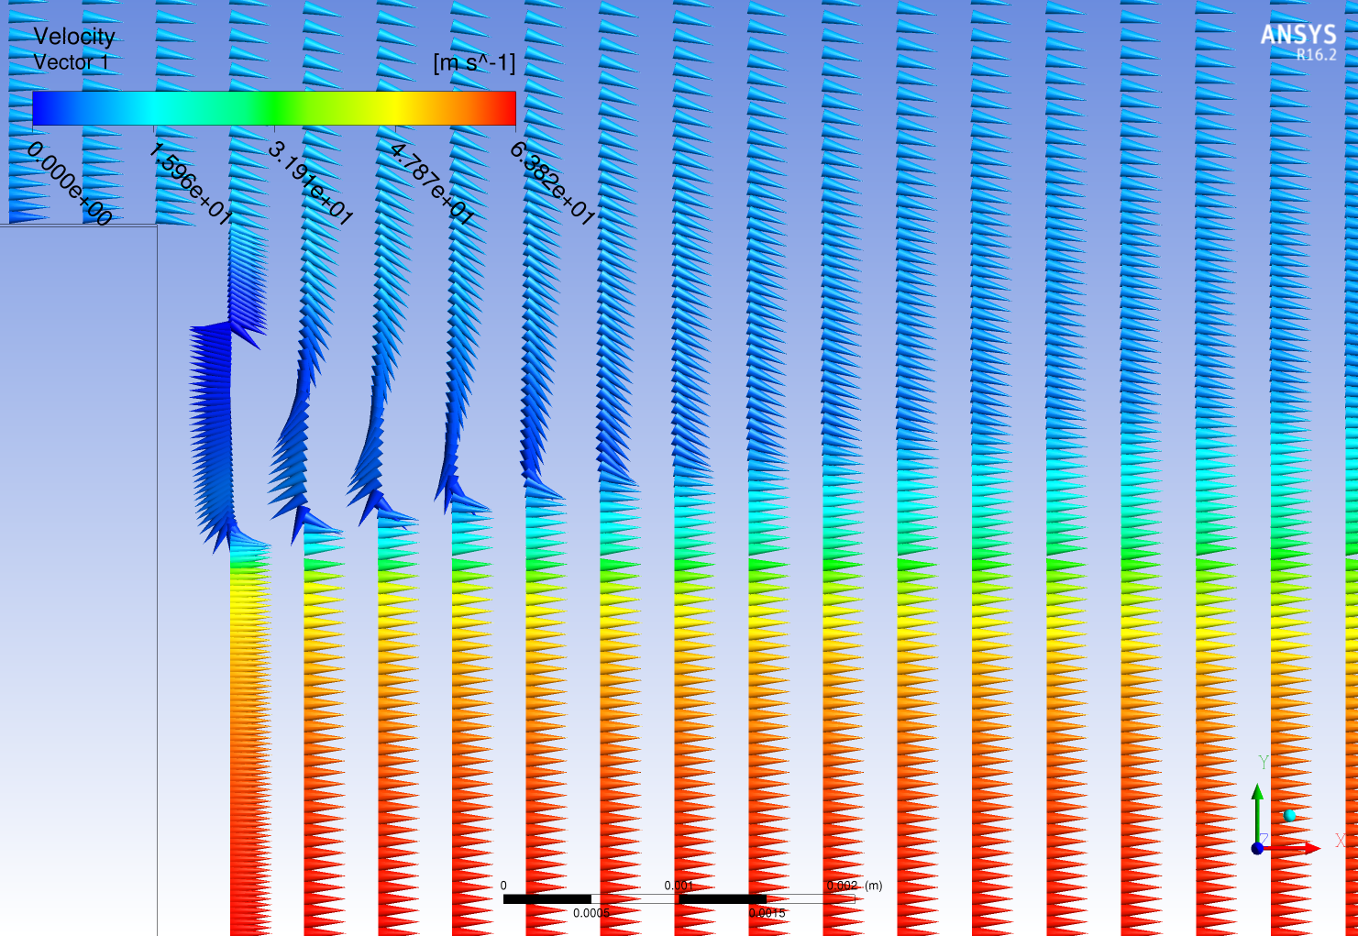

Contour plot ANSYS CFX 16.1

Streamline ANSYS CFX 16.1

Figure 4

**Model Error Study (ANSYS Fluent 17.0):**

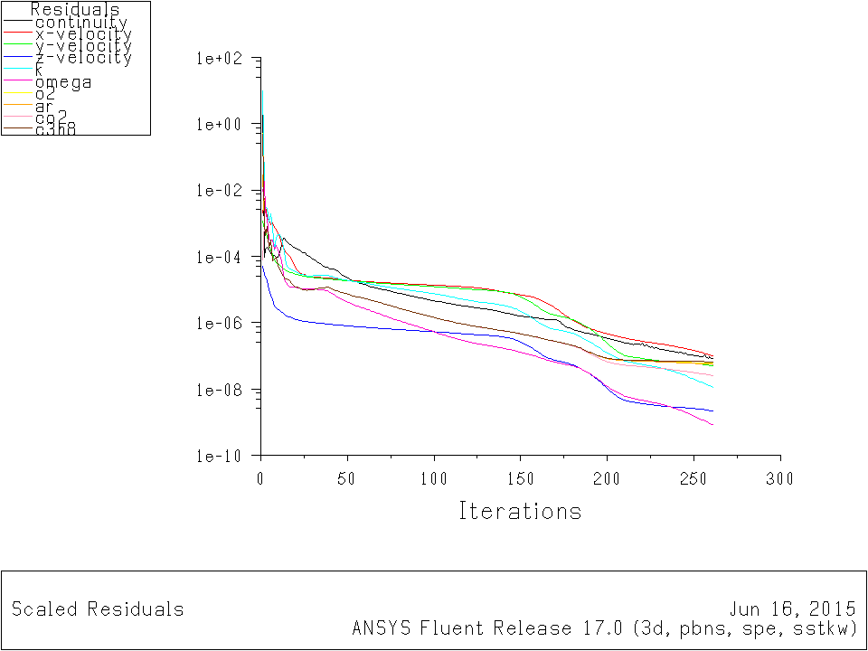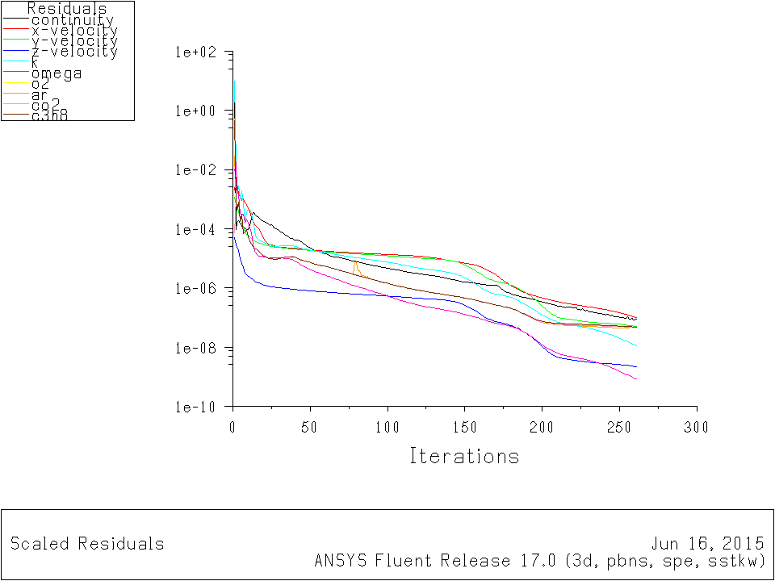

**K-ω SST with FD**

**K-ω SST with CD**

**Residual convergence history (ANSYS Fluent 17.0)**

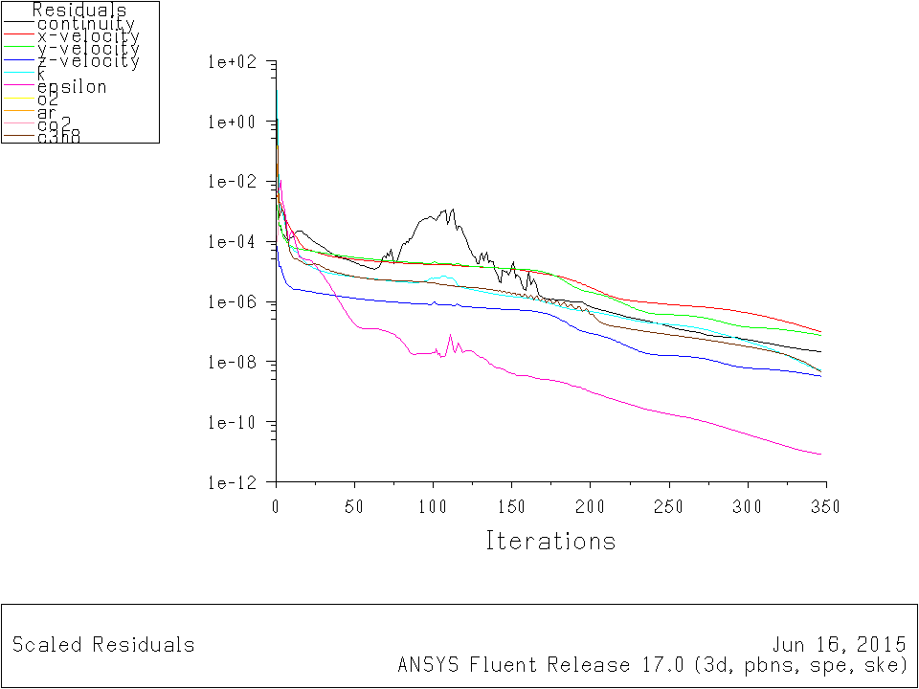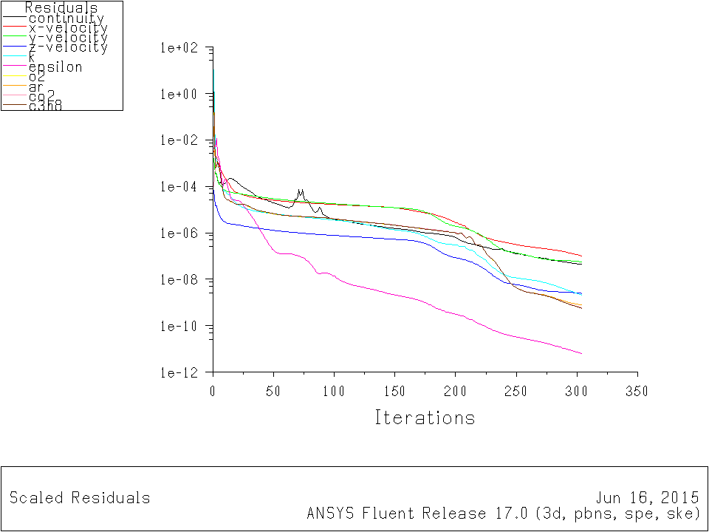

**K-ε standard with FD**

**K-ε standard with CD**

Figure 5

**Radial profile plots for ANSYS Fluent 17.0**

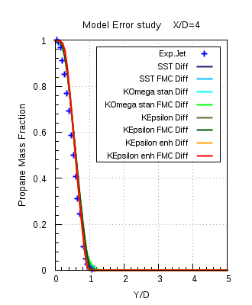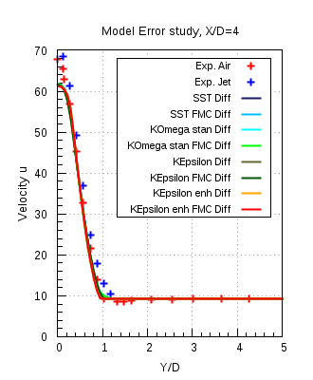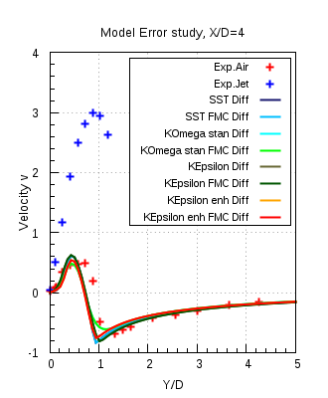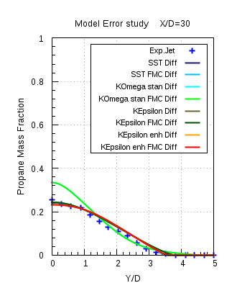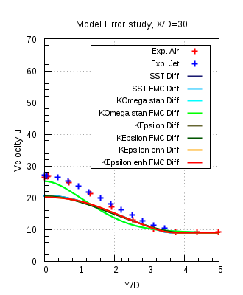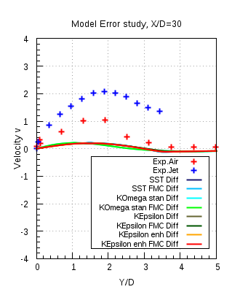Figure 6

**Sydney Bluff Body:**

**Spatial discretization study for ANSYS CFX 16.1:**

**Residual convergence history**

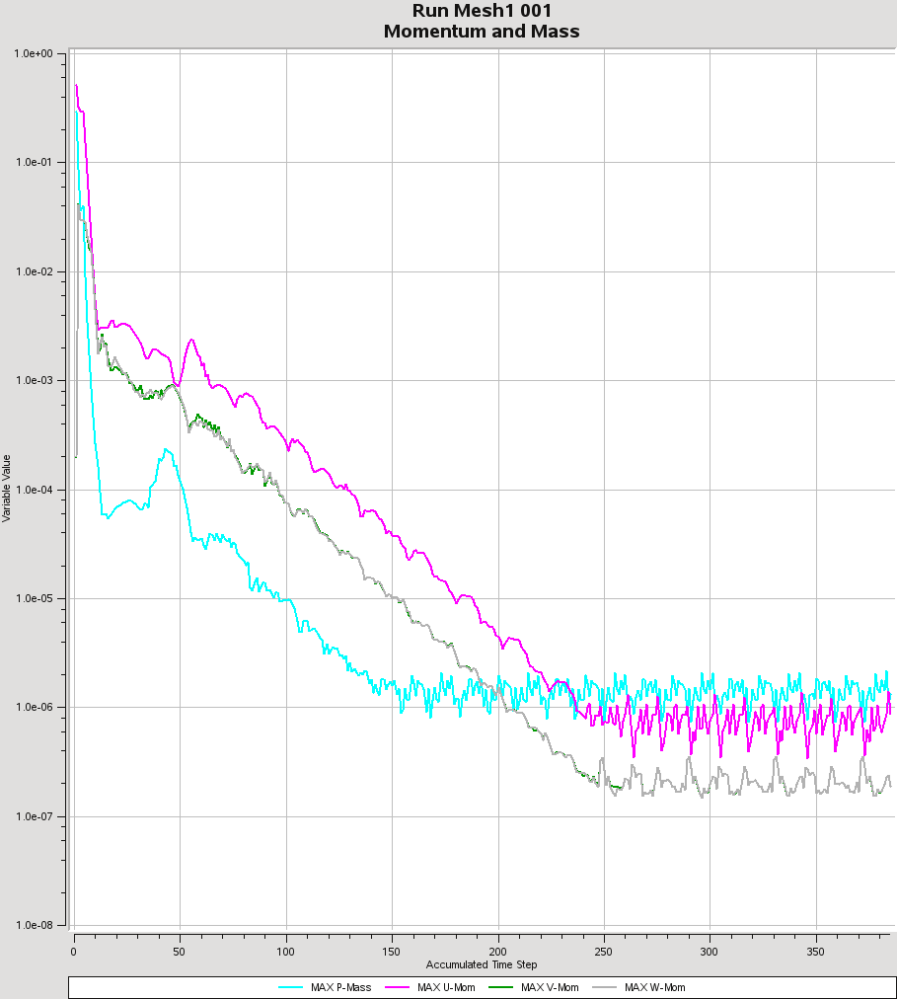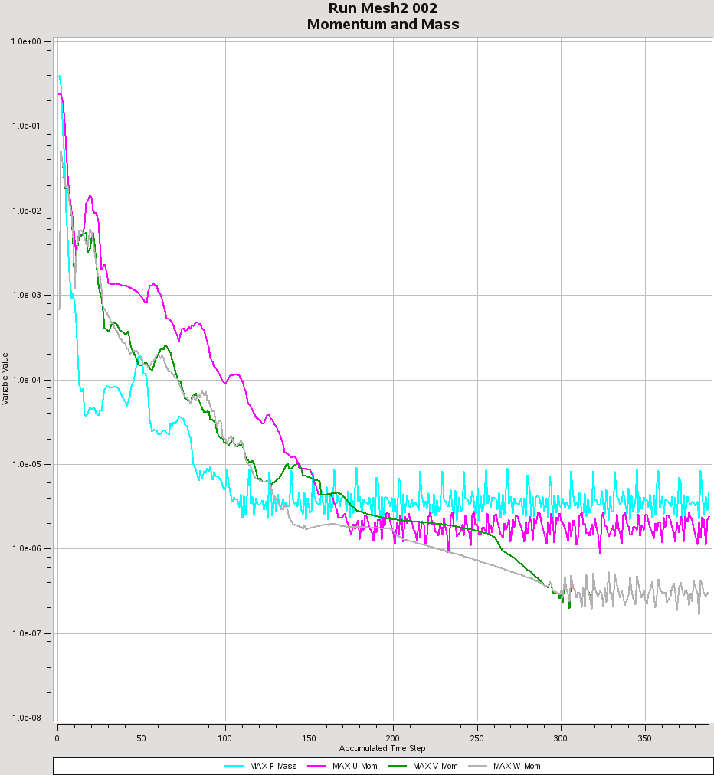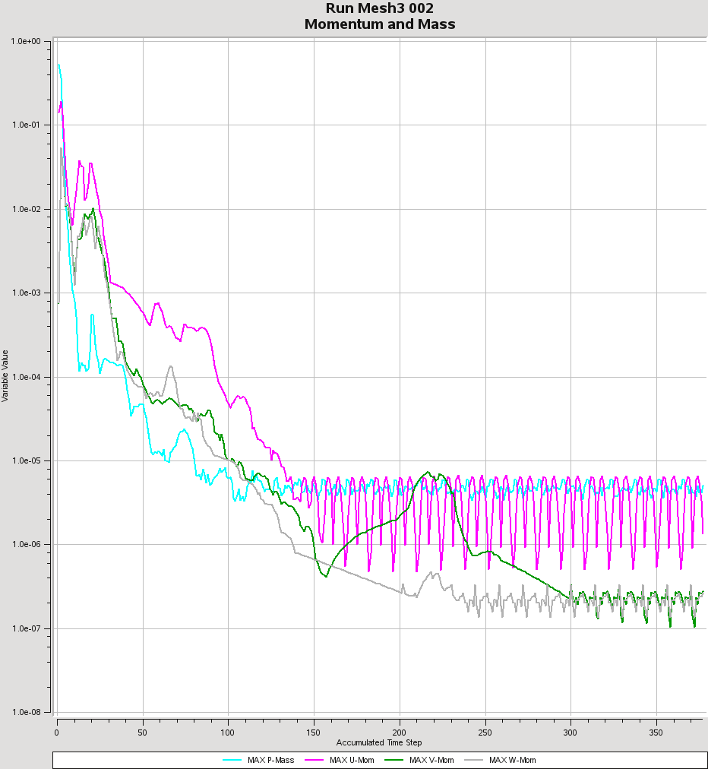

Mesh 2

Mesh 3

Mesh 1

**Imbalance monitor plots**

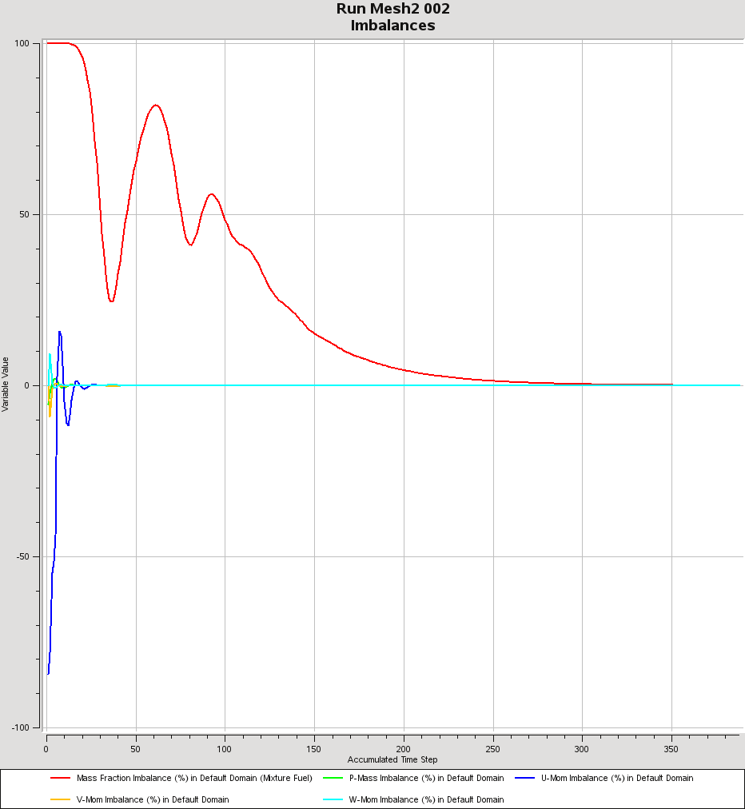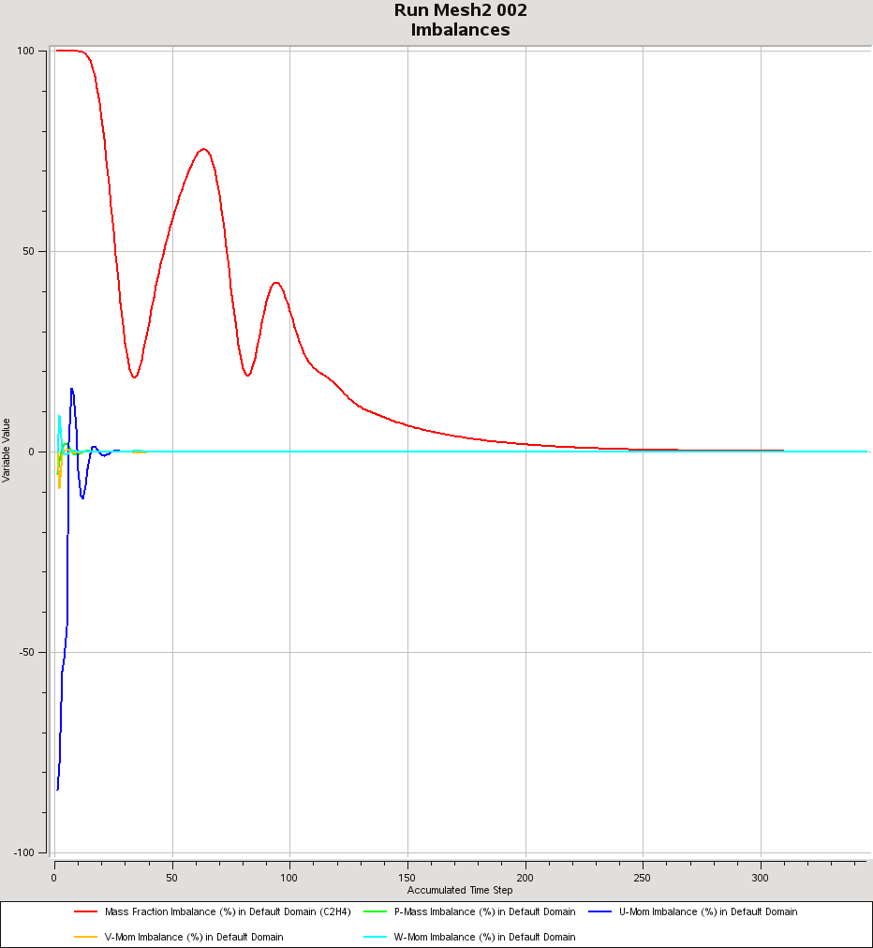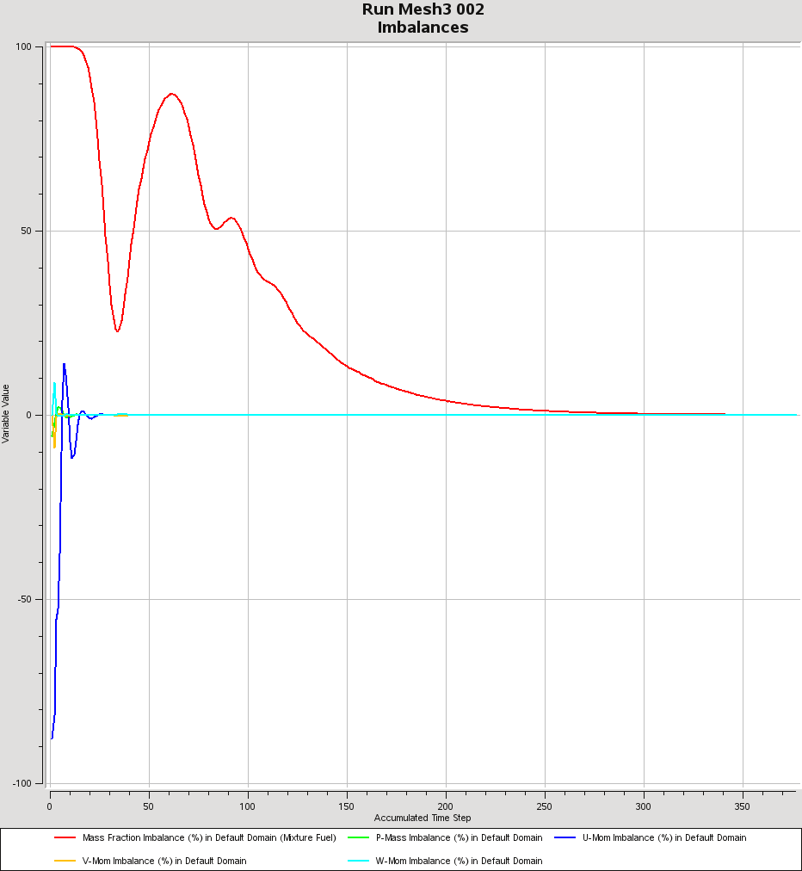

Mesh 1

Mesh 3

Mesh 2

Figure 7

**Model Error Study (ANSYS CFX 16.1)**

Residual history and Imbalance monitors for CNG fuel, UJ = 50 m/s

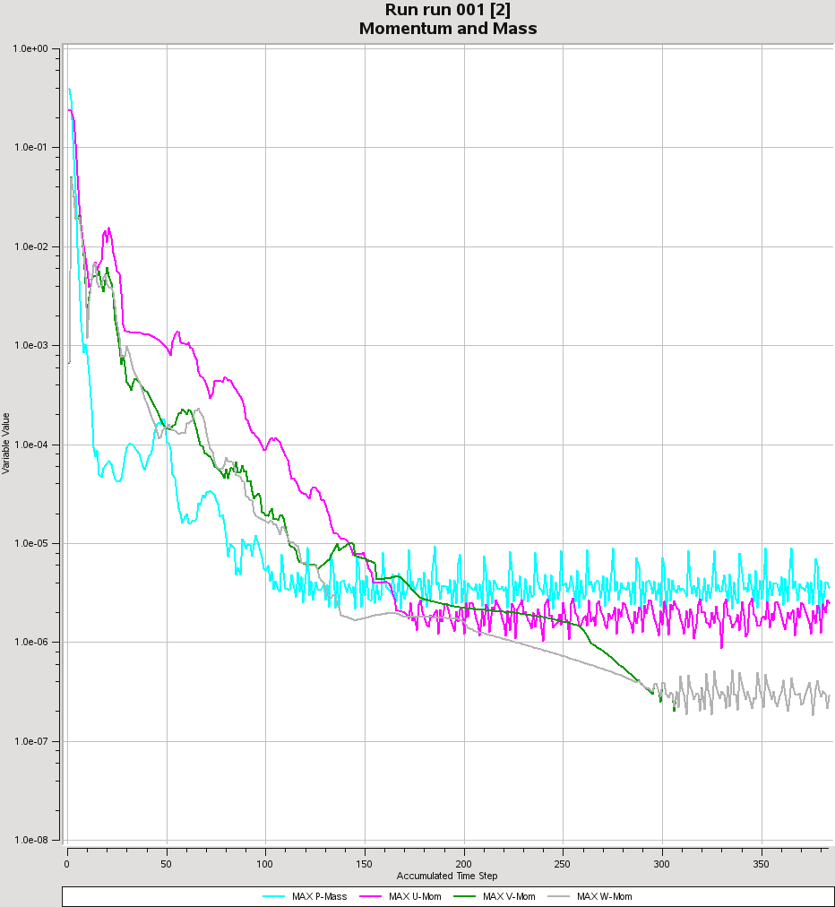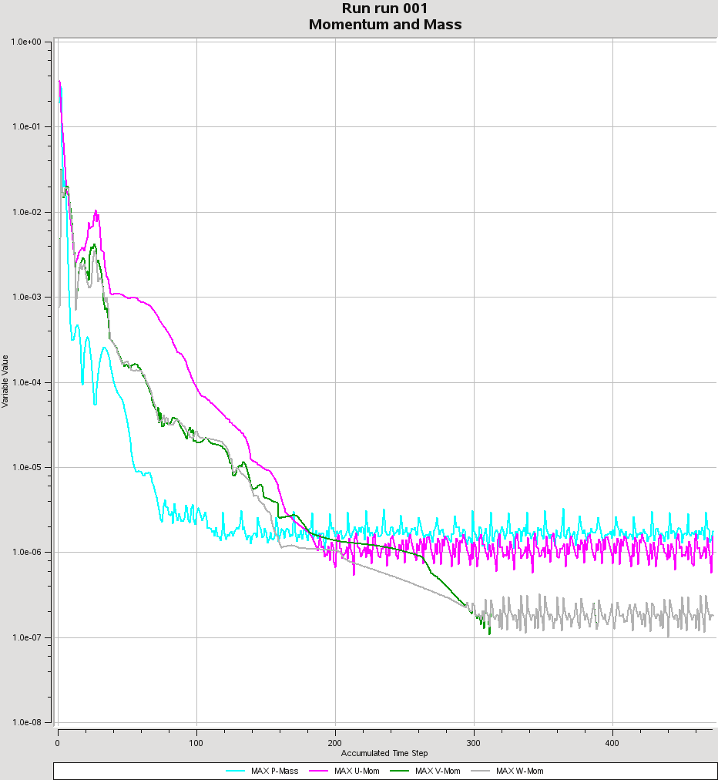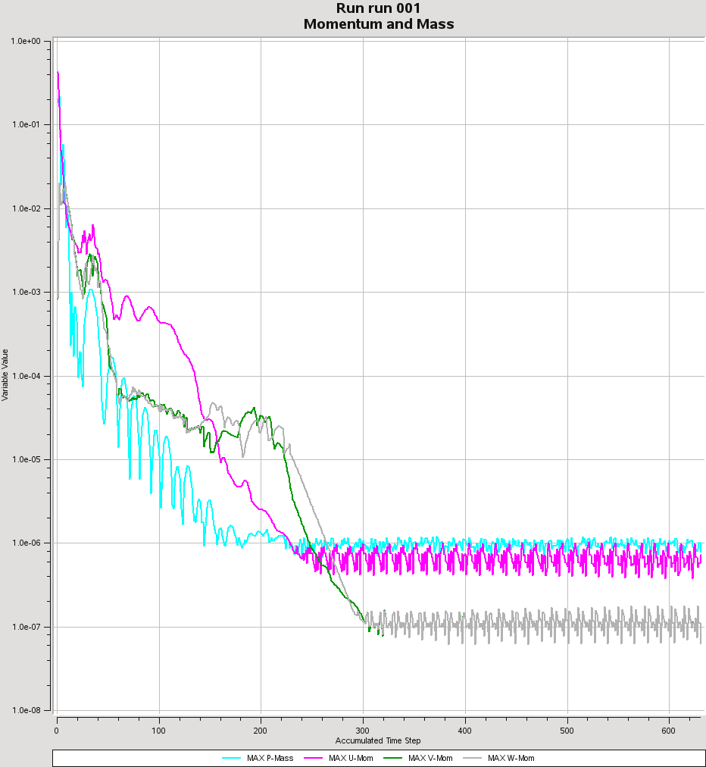

Mesh 1

Mesh 3

Mesh 2

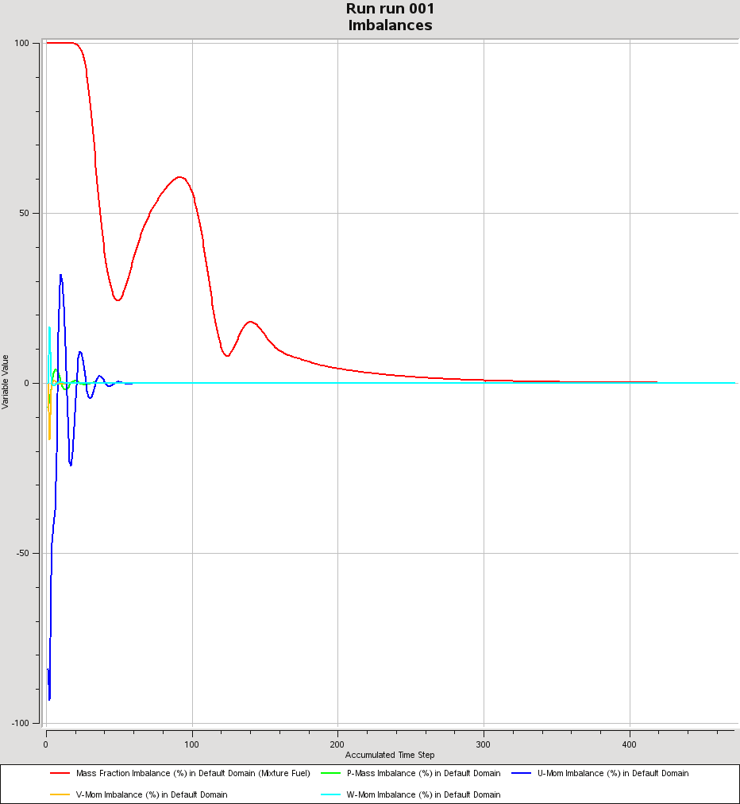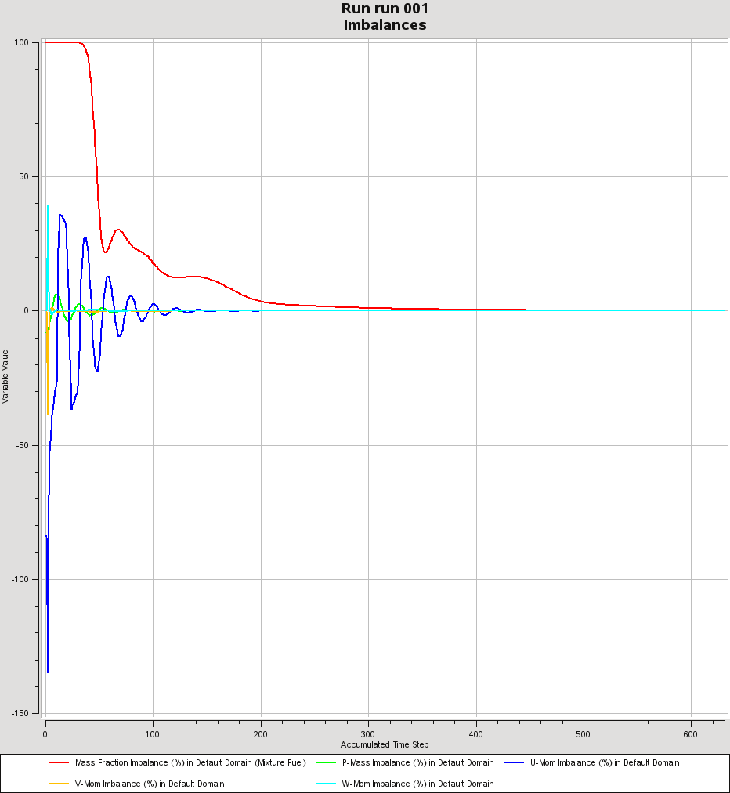

Mesh 1

Mesh 3

Mesh 2

Figure 8

**Ethylene:** UJ = 50 m/s

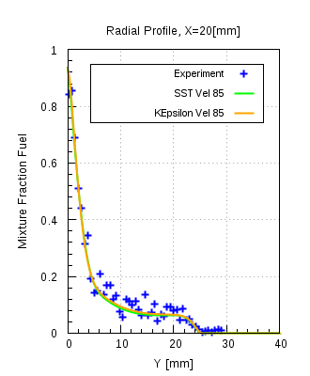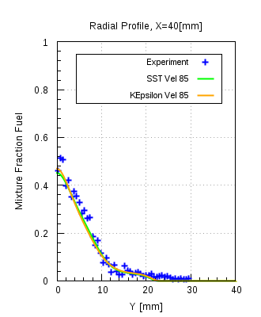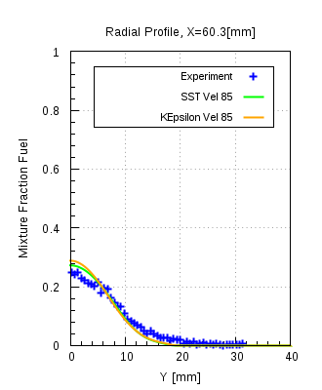

UJ = 63 m/s

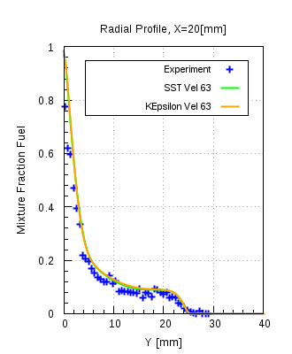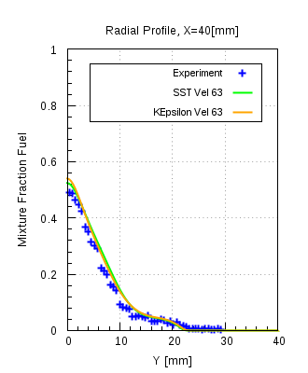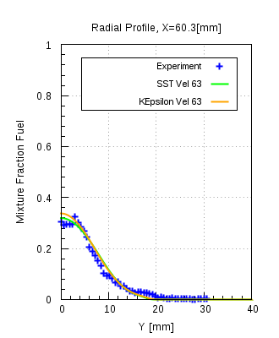

UJ = 80 m/s

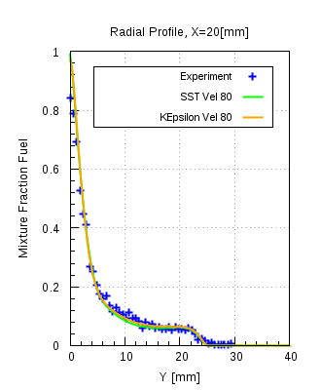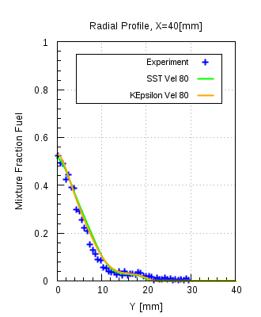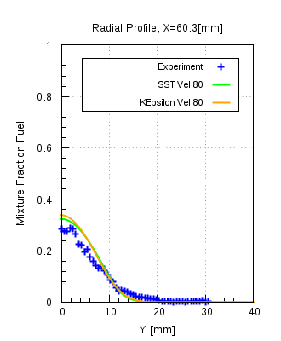

LPG: UJ = 50 & 70 m/s resp

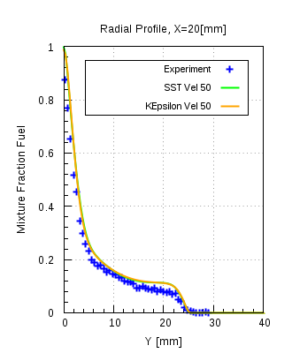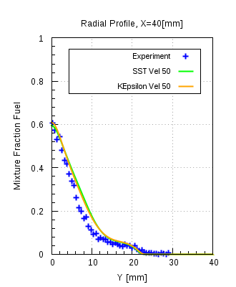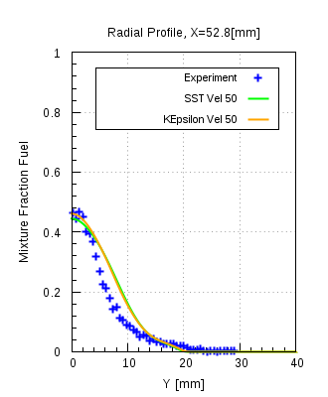

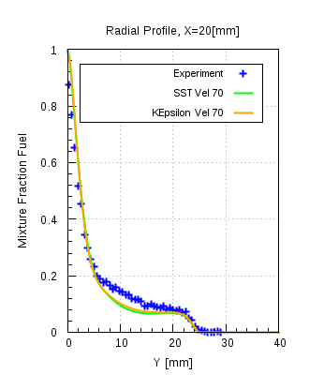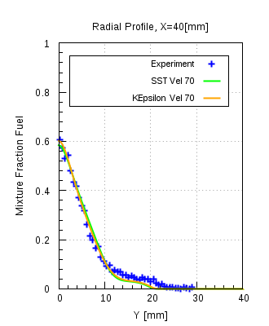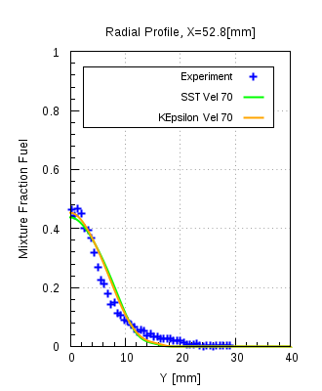

Figure 9

**Residual convergence history (ANSYS Fluent 17.0)** for CNG at UJ = 50, 85 & 143 m/s :

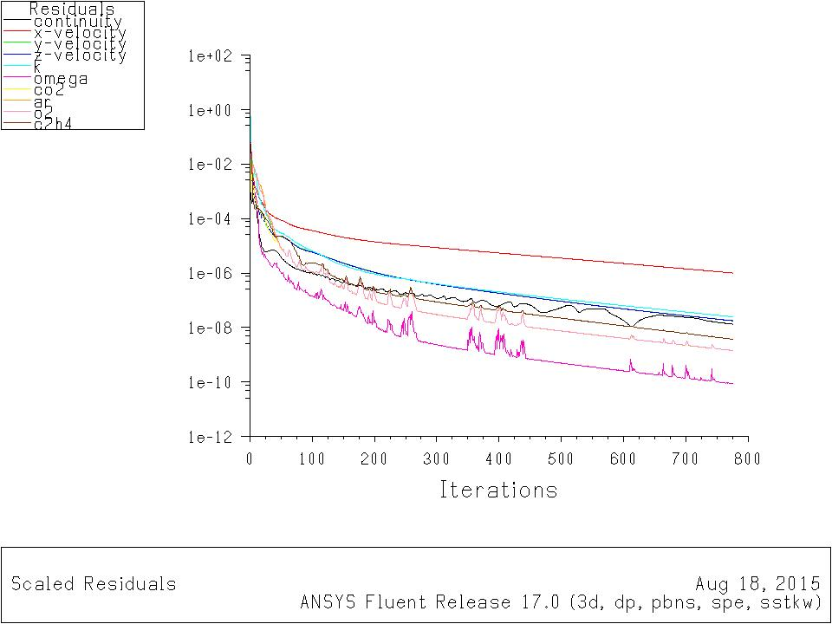 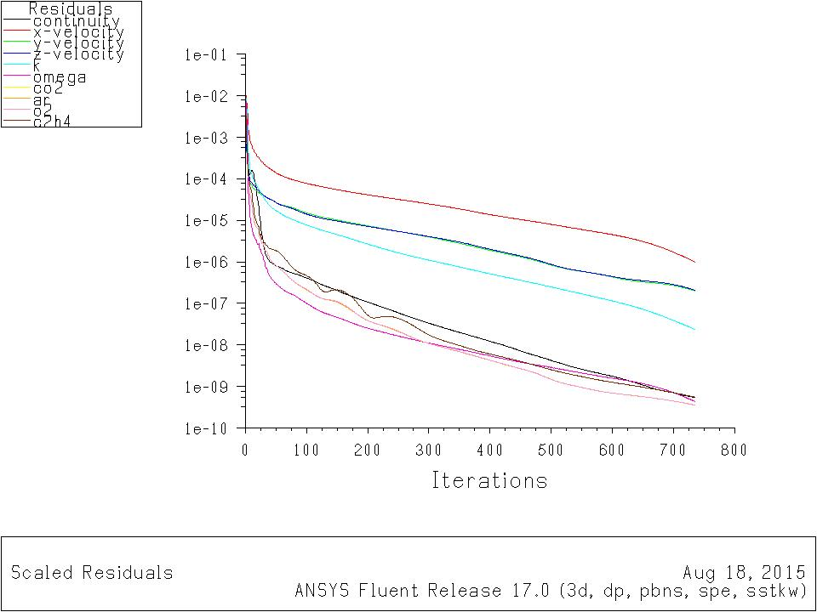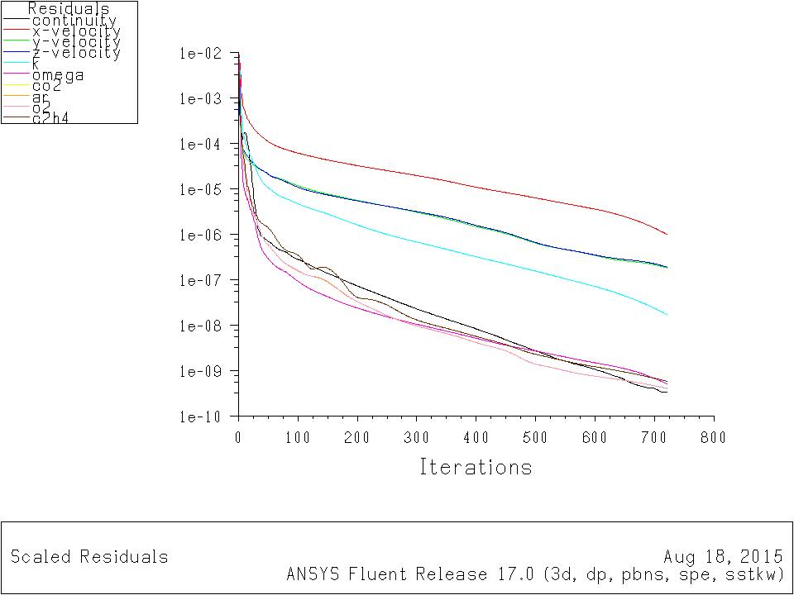

Figure 10

**Solver comparison**

**CNG fuel UJ = 50 m/s**

Figure 11

**Contour plots for CNG, UJ = 50 m/s**

Figure 12

**Ethylene:**

UJ  = 50 m/s

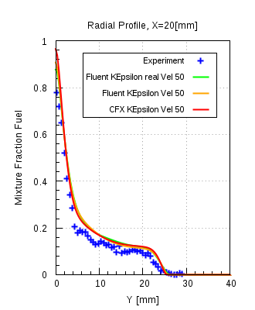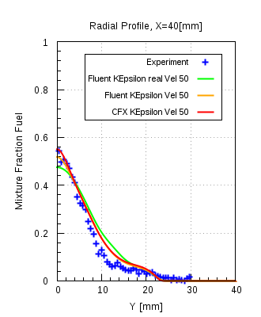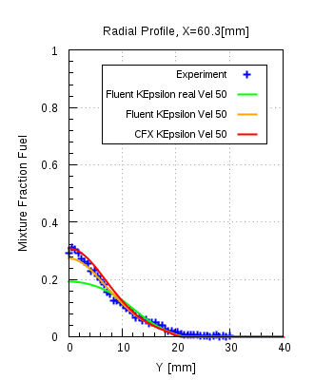

Figure 13

UJ  = 63 m/s

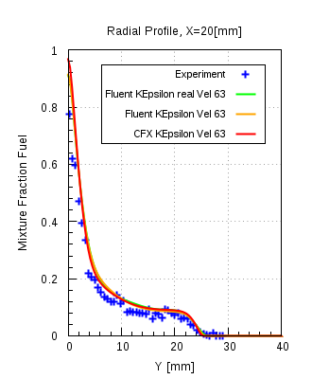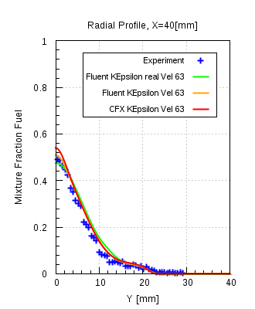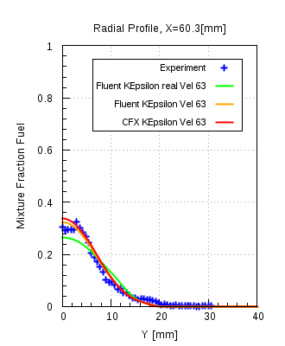

UJ  = 80 m/s

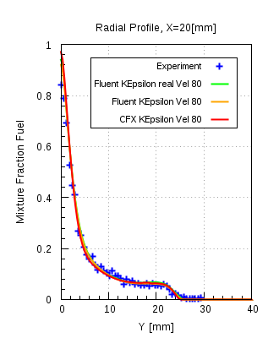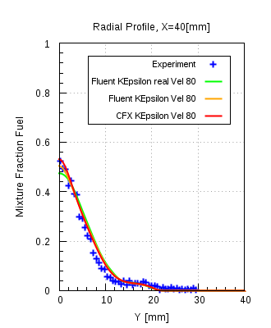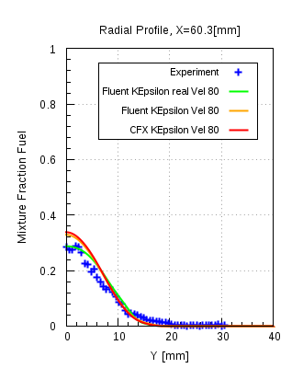

**Figure 14**

LPG (k-ε model)

UJ  = 50 m/s

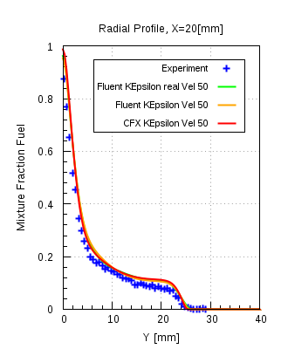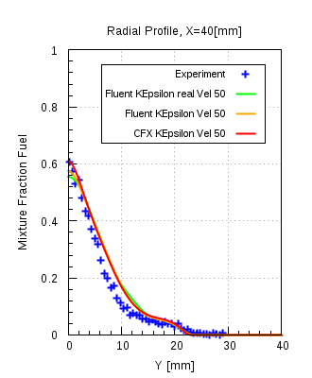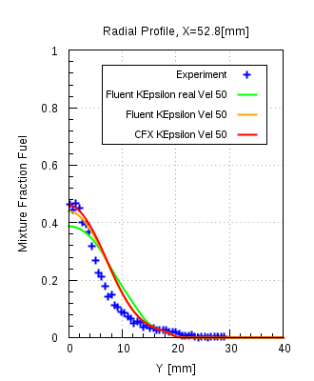

UJ  = 70 m/s

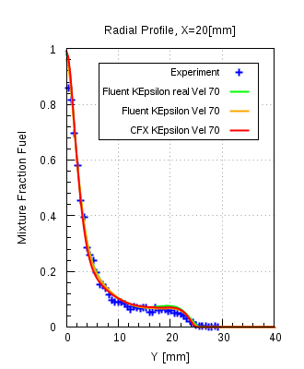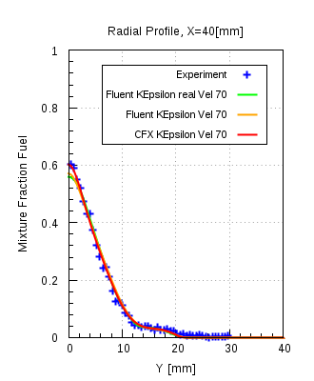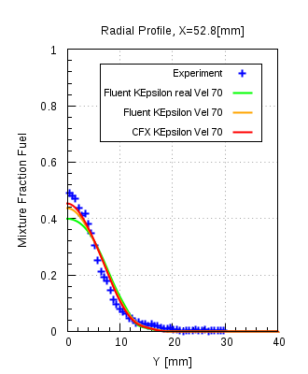

**Figure 15**

LPG(k-ω SST)

UJ  = 50 m/s

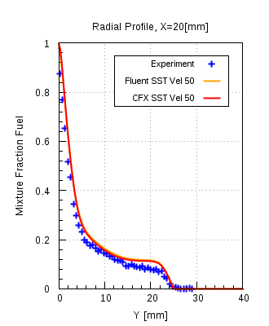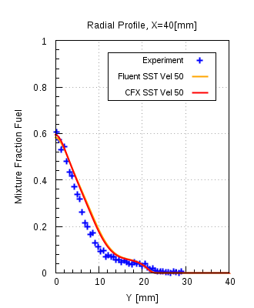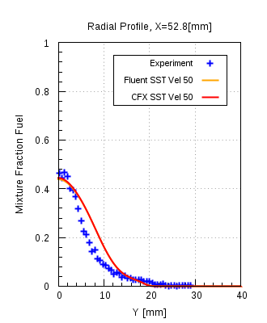

UJ  = 70 m/s

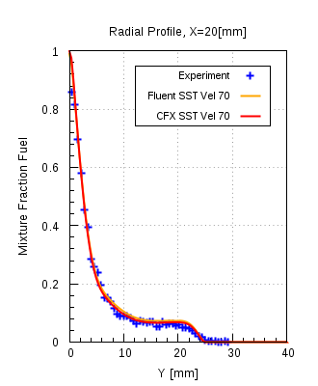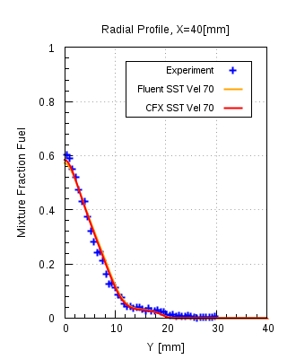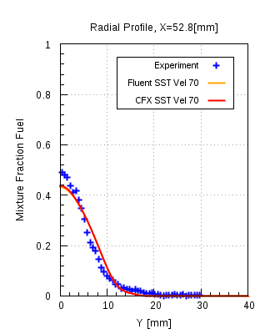

**Figure 16**